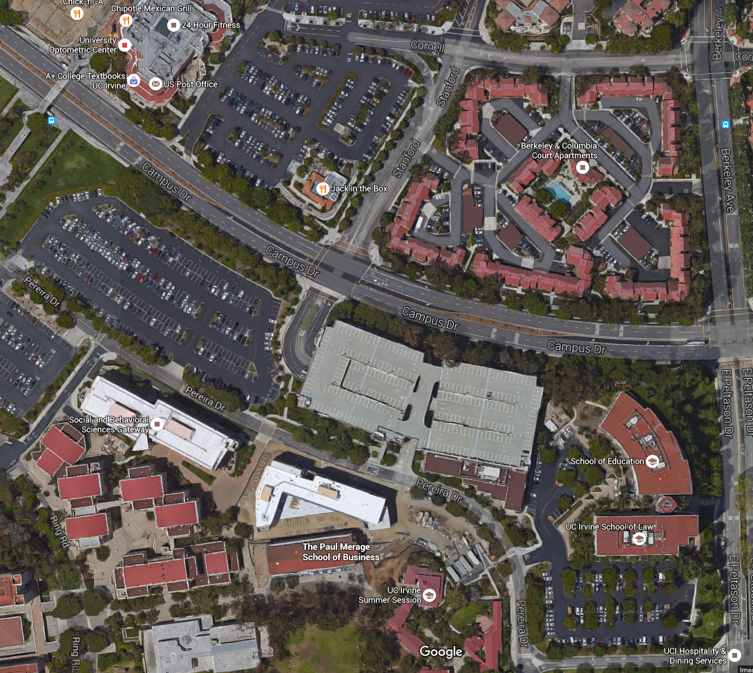

Paul Merage School
Stanford
Campus Dr.
Social Science Parking Structure
Merage School Address: 4293 Pereira Drive, Irvine, CA 92697

If you are coming from NORTH of Irvine (Los Angeles area):
Take 405 freeway south past the 55 freeway. Take the Jamboree Road exit
Turn right on Jamboree Road. Turn left onto Campus Drive. Right on Stanford into the Social Sciences parking structure.

If you are coming from SOUTH of Irvine (San Diego area):
Take the 405 freeway north. Take the Jamboree Road Exit.
Turn left onto Jamboree Road. Turn left onto Campus Drive. Right on Stanford into the Social Sciences parking structure.

If you are coming from EAST of Irvine (Riverside area):
Take the 91 freeway west to the 55 freeway south. Take the 55 freeway south to the 405 freeway south. Take the Jamboree Road exit. Turn right onto Jamboree Road. Turn left on Campus Drive. Right on Stanford into the Social Sciences parking structure.

